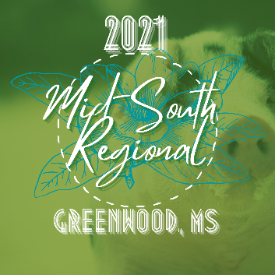

Team Purebred Mid-South Regional
Greenwood, MS- February 26-28, 2021

Friday, Feb 26-
- 2 pm – Earliest Pigs can arrive
- 5pm – 7pm – Early Check-In

Saturday, Feb 27-
- 8am – 10 am – Check IN
- 10 am – Skillathon open
- 9 am – All hogs must be on the grounds
- 11 am – Showmanship (youngest to oldest)
- Barrow show follow 10 minutes after showmanship
- Skillathon closed 5 minutes after Barrow show.
- Barn Yard Olympics 10 minutes after Barrow show
- Exhibitor Social following Barn Yard Olympics

Sunday, Feb 28-
- 8 am – Worship Service
- 9 am – Gilt Show
- Sweepstakes Awards following gilt show

