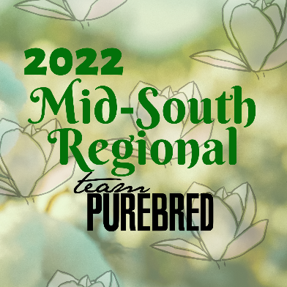

February 25-27, 2022
1304 Cypress Ave, Greenwood, MS

Friday, Feb 26-
- 2 pm – Earliest Pigs can arrive
- 5pm – 7pm – Early Check-In

Saturday, Feb 27-
- 8am – 10 am – Check IN
- 9 am – All hogs must be on the grounds
- 10 am – Skillathon open until 5 minutes after the conclusion of Gilt show
- 10 am – YQCA
- 11 am – Adult PQA
- 1 pm – Showmanship (youngest to oldest; You MUST show a Team Purebred animal in Showmanship)
- Gilt show to follow 10 minutes after showmanship (Show Order: Berk, Chester, Duroc, Hamp, Hereford, Poland, Landrace, Spot, Tamworth, York, Cross, followed by the Grand Drive: ONLY TEAM PUREBRED PIGS ARE ELIGIBLE FOR GRAND DRIVE. AS OF JANUARY 1, 2022, BERKSHIRES ARE NO LONGER CONSIDERED TEAM PUREBRED PIGS)
- Barn Yard Olympics and Exhibitor Social 10 minutes after Gilt show

Sunday, Feb 28-
- 8 am – Worship Service
- 9 am – Barrow Show (Show Order: Berk, Chester, Duroc, Hamp, Hereford, Poland, Landrace, Spot, Tamworth, York, Cross, followed by the Grand Drive: ONLY TEAM PUREBRED PIGS ARE ELIGIBLE FOR GRAND DRIVE. AS OF JANUARY 1, 2022, BERKSHIRES ARE NO LONGER CONSIDERED TEAM PUREBRED PIGS)
- Sweepstakes Awards following barrow show

• Class premiums will be handed out at the show. Premiums will NOT be mailed out.
• 10 animals per breed per sex are required for full class payment. Less than 10 will result in 50% cut on premiums
• Awards will NOT be mailed out. You will need to pick them up.

